**Week 11**

**Q1)**Two strings ***A*** and ***B*** comprising of lower case English letters are compatible if they are equal or

can be made equal by following this step any number of times:

· Select a prefix from the string ***A*** (possibly empty), and increase the alphabetical value of all the

characters in the prefix by the same valid amount. For example, if the string is ***xyz*** and we select the

prefix ***xy*** then we can convert it to ***yx*** by increasing the alphabetical value by 1. But if we select the

prefix ***xyz*** then we cannot increase the alphabetical value.

Your task is to determine if given strings ***A*** and ***B*** are compatible.

**Input format**

First line: String ***A***

Next line: String ***B***

**Output format**

For each test case, print ***YES*** if string ***A*** can be converted to string ***B***, otherwise print ***NO***.

**Constraints**

***1 ≤ len(A) ≤ 1000000***

***1 ≤ len(B) ≤ 1000000***

**SAMPLE INPUT**

abaca

cdbda

**SAMPLE OUTPUT**

YES

**Explanation**

The string ***abaca*** can be converted to ***bcbda*** in one move and to ***cdbda*** in the next move.

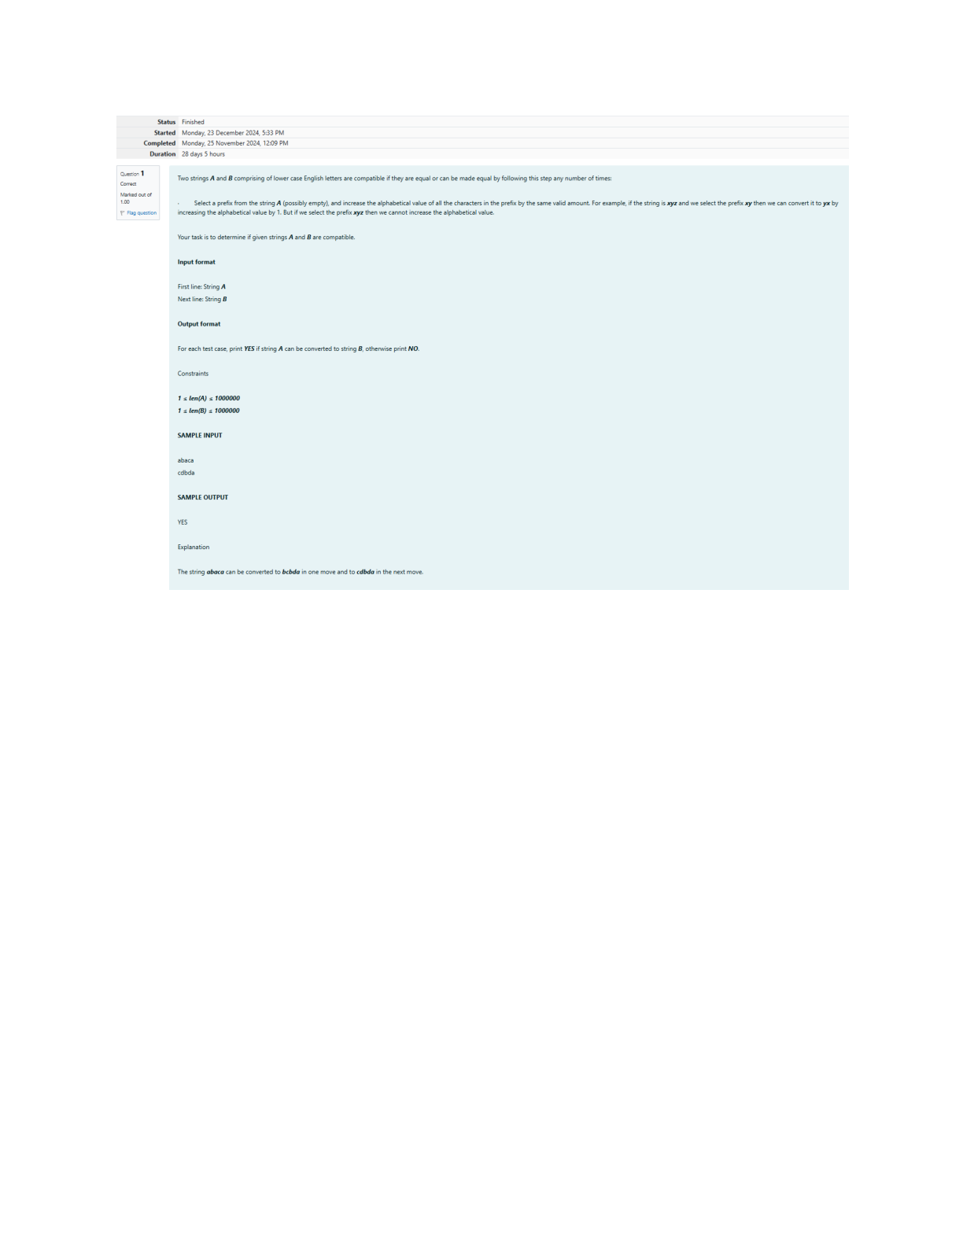

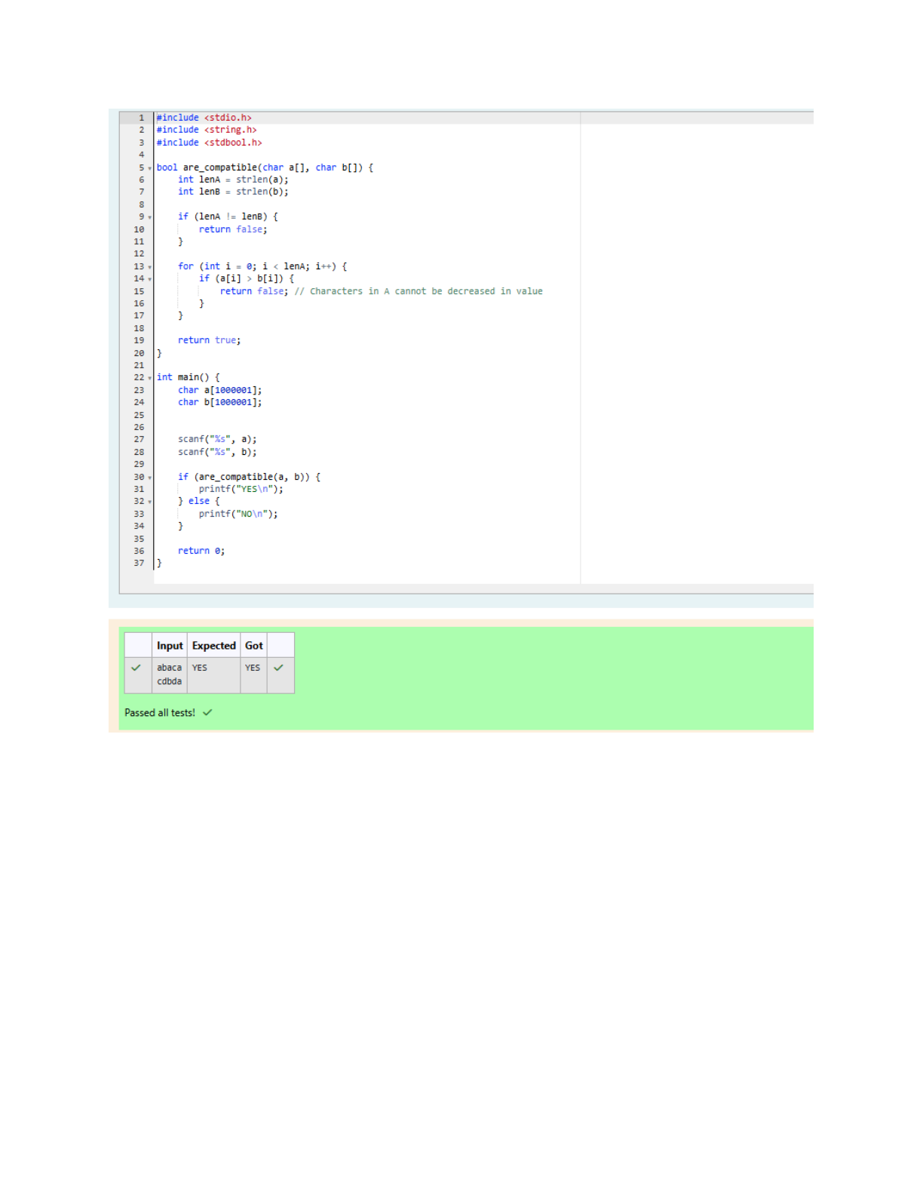

**Q2)**Danny has a possible list of passwords of Manny's facebook account. All passwords length is

odd. But Danny knows that Manny is a big fan of palindromes. So, his password and reverse of his

password both should be in the list.

You have to print the length of Manny's password and it's middle character.

**Note: The solution will be unique.**

**INPUT**

The first line of input contains the integer N, the number of possible passwords.

Each of the following N lines contains a single word, its length being an odd number greater than 2

and lesser than ***14***. All characters are lowercase letters of the English alphabet.

**OUTPUT**

The first and only line of output must contain the length of the correct password and its central let-

ter.

**CONSTRAINTS**

***1 ≤ N ≤ 100***

**SAMPLE INPUT**

4

abc

def

feg

cba

**SAMPLE OUTPUT**

3 b

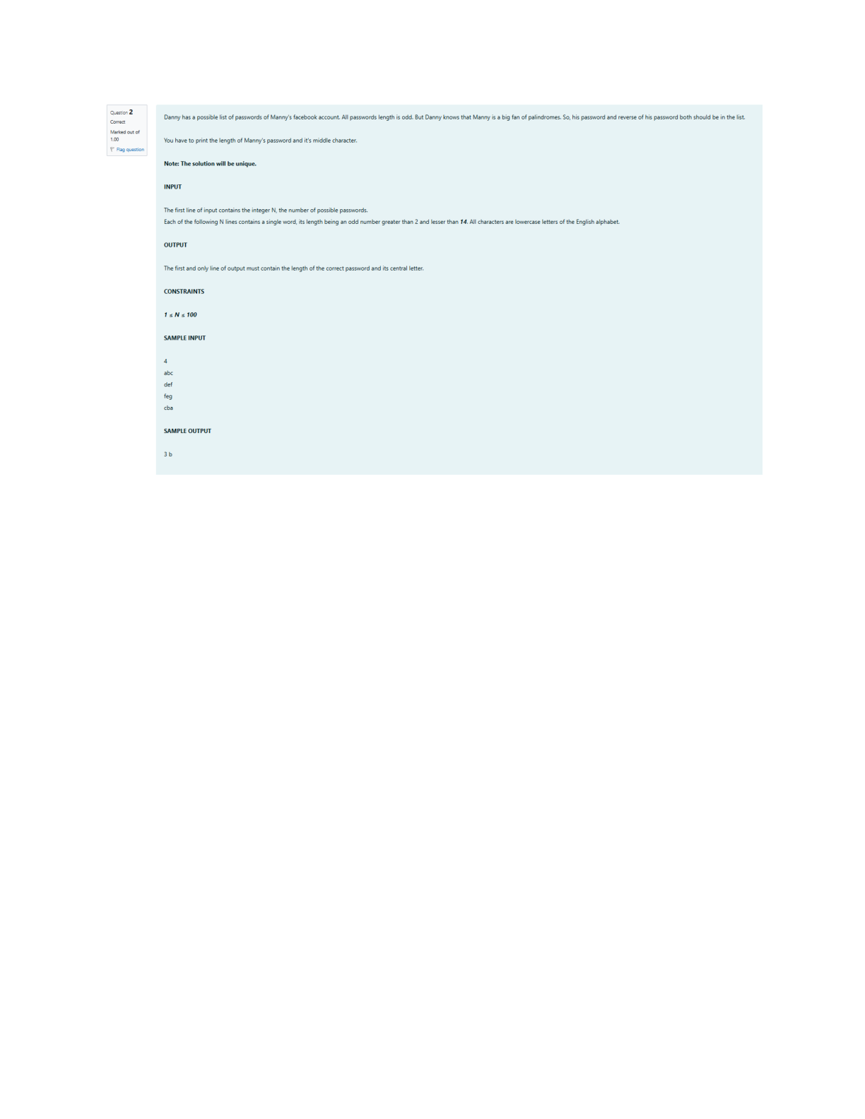

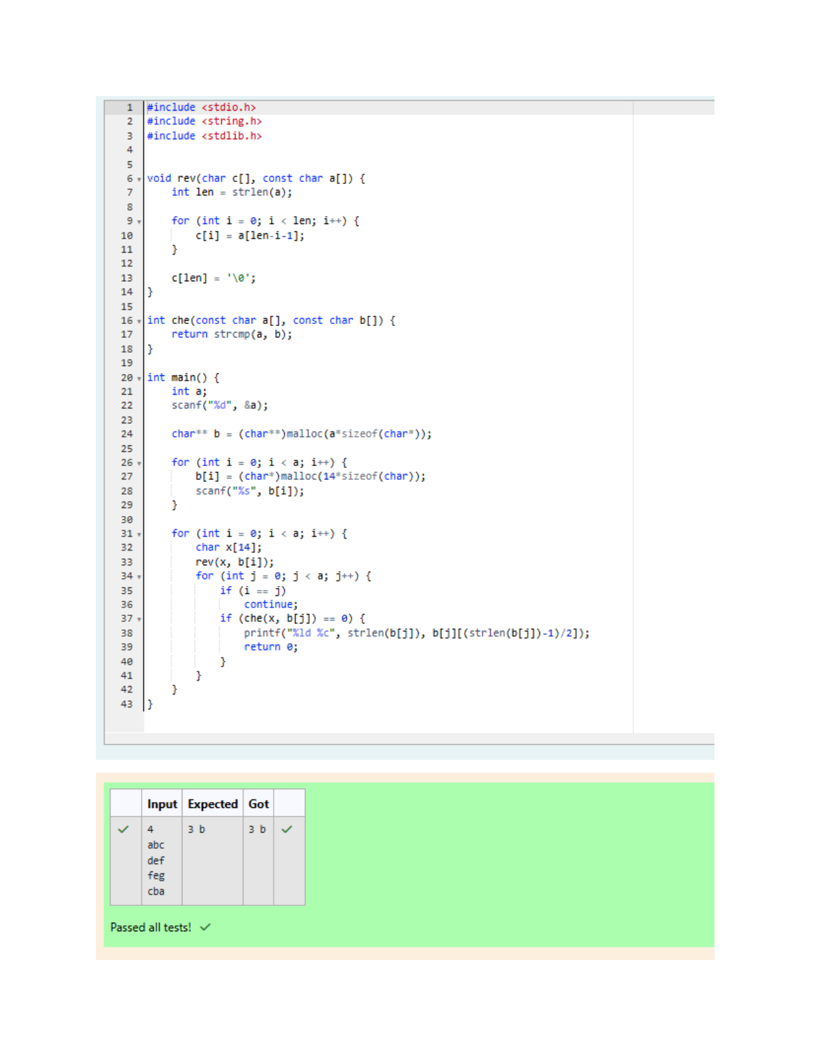

**Q3)**Joey loves to eat Pizza. But he is worried as the quality of pizza made by most of the restau-rants is deteriorating. The last few pizzas ordered by him did not taste good :(. Joey is feeling ex-tremely hungry and wants to eat pizza. But he is confused about the restaurant from where he should order. As always he asks Chandler for help.

Chandler suggests that Joey should give each restaurant some points, and then choose the restau-rant having **maximum points**. If more than one restaurant has same points, Joey can choose the one with **lexicographically smallest** name.

Joey has assigned points to all the restaurants, but can't figure out which restaurant satisfies Chan-dler's criteria. Can you help him out?

**Input:**

First line has N, the total number of restaurants.

Next N lines contain Name of Restaurant and Points awarded by Joey, separated by a space. Restau-rant name has **no spaces**, all lowercase letters and will not be more than 20 characters.

**Output:**

Print the name of the restaurant that Joey should choose.

**Constraints:**

1 <= N <= 105   
1 <= Points <= 106

**SAMPLE INPUT**

3   
Pizzeria 108   
Dominos 145   
Pizzapizza 49

**SAMPLE OUTPUT**

Dominos

**Explanation**

**Dominos** has maximum points.

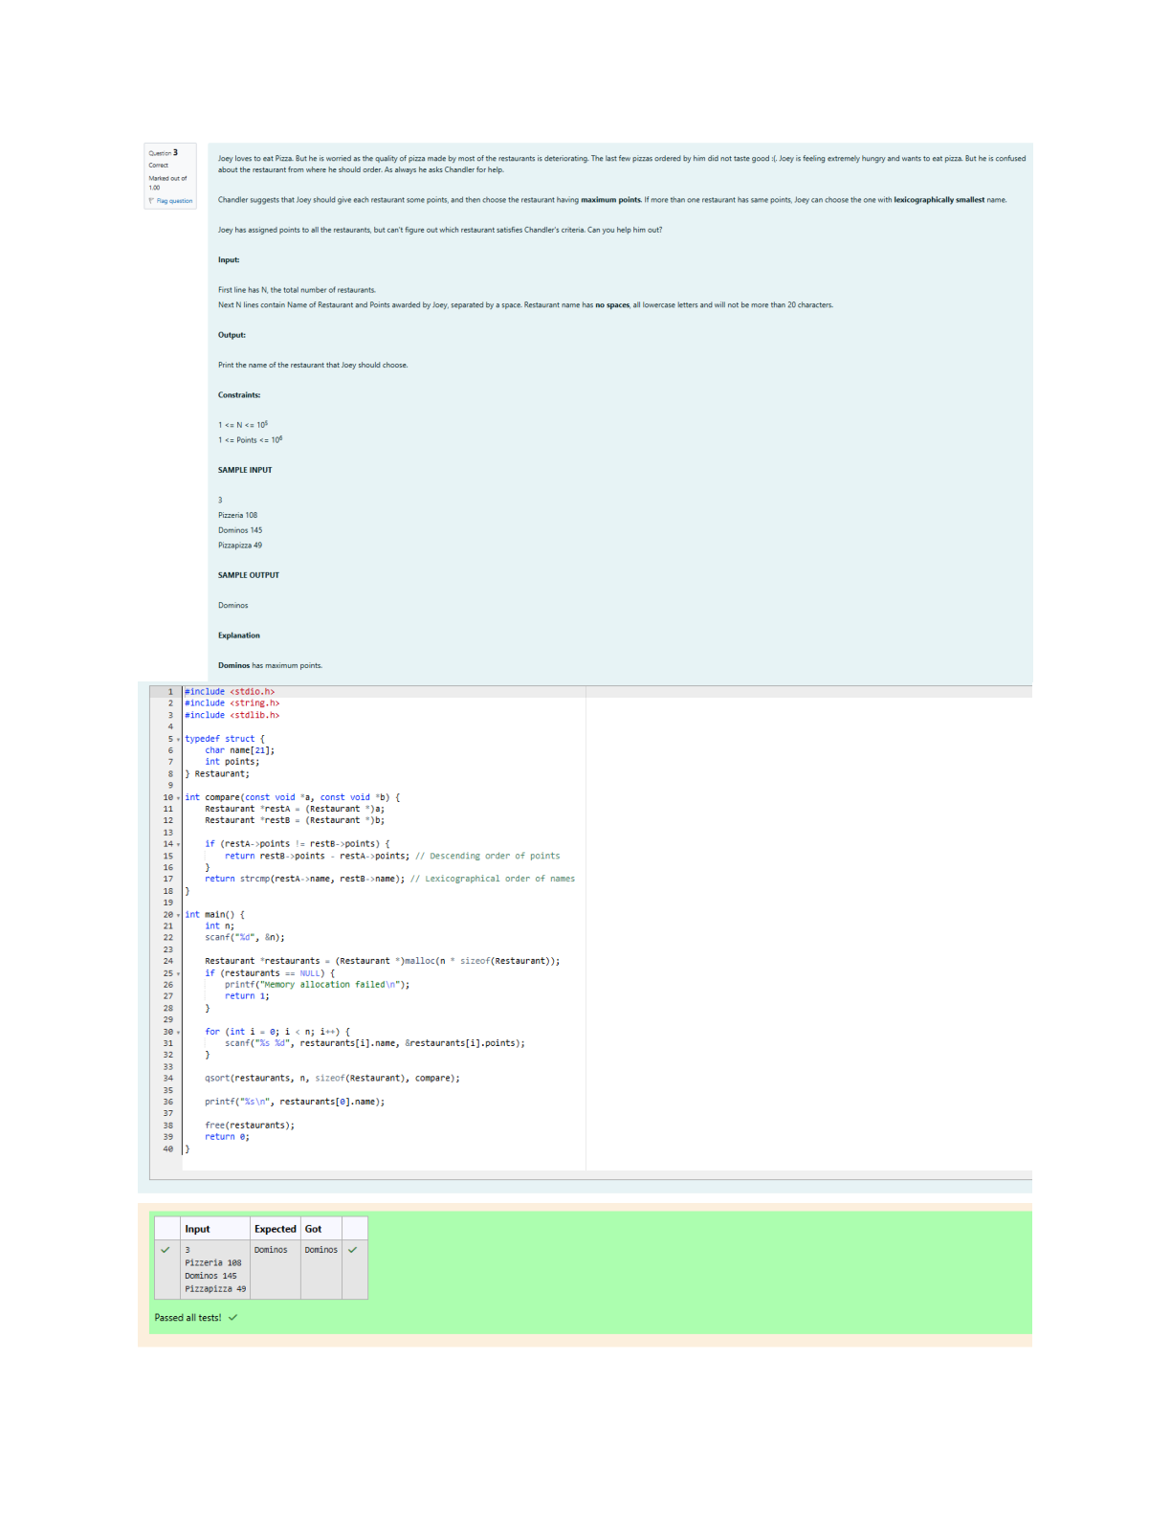

**Q4)**These days Bechan Chacha is depressed because his crush gave him list of mobile number some of them are valid and some of them are invalid. Bechan Chacha has special power that he can pick his crush number only if he has valid set of mobile numbers. Help him to determine the valid num-bers.

You are given a string "S" and you have to determine whether it is Valid mobile number or not. Mo-bile number is valid only if it is of length 10 , consists of numeric values and it shouldn't have prefix zeroes.

**Input:**

First line of input is T representing total number of test cases.

Next T line each representing "S" as described in in problem statement.

**Output:**

Print "YES" if it is valid mobile number else print "NO". Note: Quotes are for clarity.

**Constraints:**

1<= T <= 103   
sum of string length <= 105

**SAMPLE INPUT**

3   
1234567890   
0123456789   
0123456.87

**SAMPLE OUTPUT**

YES   
NO   
NO

